WIP Toolkit - Panel Discussion Resources – Samples

Questions Sample

Panel Discussion questions will vary greatly depending on the topic of the panel discussion. Develop 4-6 strong questions for your panel. The following are a sample set of questions from a panel discussion, “Women Influencing the Industry: A Local Perspective on Developing Your Journey”.

- How did you get to where you are now? Is it something you had planned? Did you have a career path in place when you started? Have you created it as you’ve gone along?
- How do you develop your own brand?
- If you were to give a young woman who aspires to reach high places in the pharmaceutical and/or healthcare industries a "heads up" about one thing she will likely encounter in her career path - that you also experienced on your career path - what would it be?
- People talk about being flexible and open to taking risks and pursuing new opportunities - how would you say you have grown into you role by being flexible, taking risks and seizing opportunities?
- How do you reconcile personal and professional growth?

Abstract Sample

Panel Discussion abstracts will vary greatly depending on the topic of the panel discussion. The following is a sample abstract from a panel discussion, “Women Influencing the Industry: A Local Perspective on Developing Your Journey”.

Women Influencing the Industry - A Local Perspective on Developing Your Journey
“I know a little something about a woman in a man’s profession,” was presumably first spoken by Queen Elizabeth during her reign from 1558 - 1603. Now, however, a growing number of women are making their marks in the biopharma industry, paving the way for generations to come so that people won’t think “man” when they hear the word “engineer.”
Women have proven their capabilities throughout the biopharma market and continue to bring technical knowledge and insight to the workplace. Come meet a panel of local, leading ISPE-CASA women to hear how they have influenced the industry and paved their own paths.
The following are key themes for our panel discussion:
- Set goals
- Set boundaries
- Build confidence – step out of your comfort zone
- Love your life
- Know thyself; the more knowledge you have, the more you can contribute

Key Takeaways Sample
Panel Discussion key takeaways will vary depending on the topic of the panel discussion. Develop approximately 5-15 key takeaways for your panel. List in order of importance for the panel discussion. The following are a sample set of key takeaways from a panel discussion, “Women Influencing the Industry: A Local Perspective on Developing Your Journey”. With each takeaway, it is recommended to add a short sentence.

1. Set goals
2. Set boundaries
3. Build confidence – step out of your comfort zone
4. Love your life
5. Know thyself; the more knowledge you have, the more you can contribute
6. Be involved – get connected
7. Look “back” and help
8. Lead by example
9. Learn how to learn
10. Know your audience (women v. men)
11. Own your development and career path
12. Be comfortable with the unknown
13. Understand realities – it’s not all perfect, but you just keep going
14. Make your job what you want it to be
15. Utilize support networks
16. Find mentors
17. Join professional organizations

Bio Sample

First Name Last Name, Credentials
Company
Title
Country
Email address

[Insert first name] is the [insert title] at [insert company]. [Insert first name] has a wealth of experience including [insert relevant prior experience]. He/she is responsible for [insert major responsibilities].

Prior to joining company, [insert first name] was the [insert position]. He/she was responsible for [insert responsibilities].

First Name has served clients in the [insert industries]. [Insert first name] holds [insert degrees] from [insert school name/state].

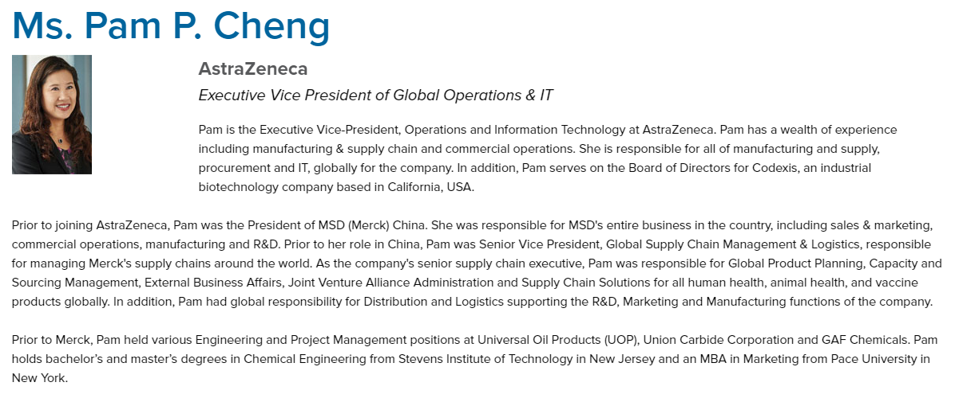

Social Media Post Sample
Social media’s involvement in your event is actually integrated into three distinct phases:
- Leading Up to your Event
- During your Event
- After your Event

Tips to Build Engagement for an Event
- Share helpful tips
- Share motivational quotes
- Share something funny
- Share stories of success
- Promote a cause
- Create lists

Sample LinkedIn Post:
Impactful question posed to panelist? Learn from Panelist(s) at ISPE’s Women in Pharma® on [INSERT DATE].

For example:

Does the pharmaceutical industry need to up their game in relation to quality and innovation? Learn what Francois Sallans, Chief Quality Officer at Johnson & Johnson, thinks about this topic.

Sample Twitter Post:
Learn why you could benefit from mentoring from @Panelist Name at #Event Name

Examples:

@ISPE_CASA presents first ever local Women in Pharma® panel. 10:00-1045 @ the ISPE Tech Conference next week. I'm excited to be on panel.

In the third installment of this 12-month series, we discuss a core mission of #WomenInPharma: paying it forward. http://bit.ly/2xJgnpY

