The ISPE Great Lakes Chapter (GLC) has established a scholarship for students who seek a career in the life sciences industry. The number of scholarships to be awarded is to be determined. The scholarship amount will be $500.

The ISPE GLC Scholarship will be awarded to an eligible student with a completed application. The awarded student(s) will be selected by the board of directors of ISPE GLC. The eligibility requirements and applicant information are located below.

Eligibility Requirements:

* Have completed at least two years of undergraduate education at time of the award. Graduate students are also encouraged to apply.
* Be a full-time student enrolled in an accredited university or college that is withing the Great Lakes Chapter’s geography (Wisconsin, Illinois, Indiana, Michigan, Ohio, and Kentucky).

A completed application is to include the following items:

* Applicant Information Form
* Essay (See applicant information form for essay requirements)
* Proof of registration for the Fall 2021 or Spring 2022 semester via a copy of class schedule with applicant’s name.
* Resume including but not limited to GPA, organization involvement, research, publications, and/or internship experience.
* Letter of recommendation (maximum of 1 letter, optional)

**Deadline for submissions:** November 26, 2021

Please submit an electronic copy of your scholarship application to the following email address: **ispeglc@gmail.com**

Winner(s) will be informed of scholarship award no later than December 17, 2021 and will be announced on the ISPE Great Lakes Chapter’s [LinkedIn](https://www.linkedin.com/company/ispe-great-lakes-chapter/?viewAsMember=true) page.

Please direct questions or concerns regarding the ISPE GLC Scholarship to Ben Balster, [BBalster@plusgroups.com](mailto:BBalster@plusgroups.com).

Thank You to Our Scholarship Sponsors!

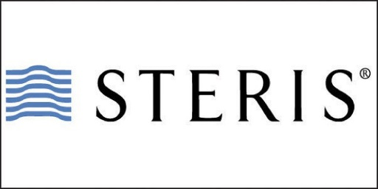

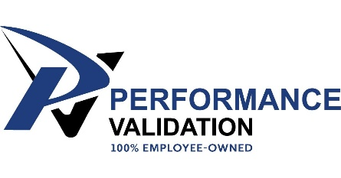Jacobslogo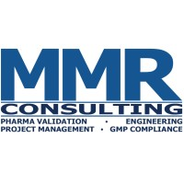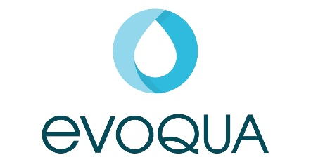

Individual Contribution from ISPE GLC Member Steven Shull

| 2022 ISPE GLC Scholarship Applicant Information | |
| --- | --- |
| Applicant Information | |
| Name: | |
| University: | Year: |
| Major: | Minor: |
| Email address: | Phone: |
| ISPE Member Number (if applicable, not required): | |
| Short Answer Questions | |
| 1. Explain how your degree relates to the life science industry: | |
|  | |
| 1. What are your career objectives? | |
|  | |
| 1. Explain what experiences or accomplishments have benefited you most, and why, including lessons learned: | |
|  | |
| 1. Describe the life science activities and related organizations that you have participated in over the last 12 months: | |
|  | |
| 1. What other information not covered in this application should we consider during the selection process? | |
|  | |
| Essay | |
| In 1000 words or less explain how your career journey will impact the life sciences industry. | |
| Please provide the essay in this document on the following page: | |