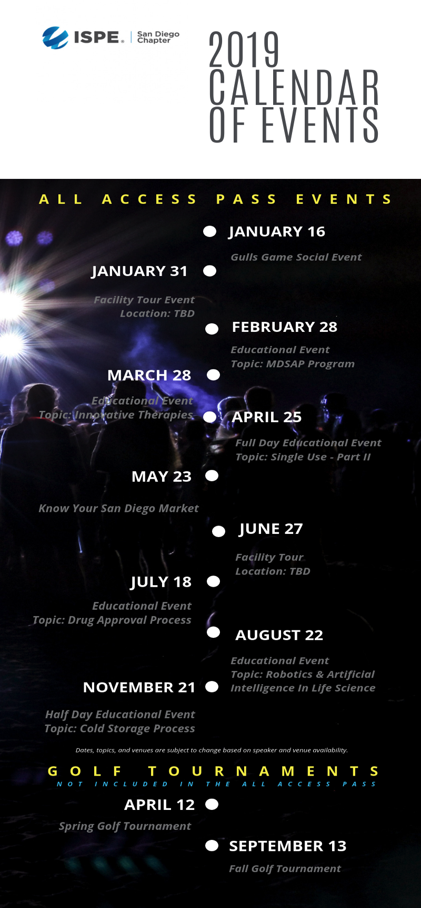

2019 Annual Pass

Save Time!
In order to help cut time spent on reimbursement forms, the ISPE San Diego Chapter is offering an Annual Pass to cover all meetings for the year. Attend all ISPE San Diego technical offerings, social events and facility tours for one price. (Golf Tournaments not included.)

Lock in your Attendance Now!
To take advantage of the entire year, please make sure to lock in your spot today. RSVP is still required for all events (a quick email is sufficient). To secure your Annual Pass, please register online at: http://atdevents.net/register.php or return the attached form with your payment.

Please Note:
1. Annual Passes are available to ISPE Members Only.
2. Registration Required for All Events: All event notices will be sent via email. Once your Annual Pass has been reserved and paid for, you can log on and register for each event as you receive notice for that event. Please register online selecting "Company or Personal Check" as your payment option. If you need assistance with registration, please contact Rob Fleming at rob.fleming@yahoo.com
3. Dates, topics and locations may change due to availability of speakers and venue.
4. Annual Passes are for one person only and are not transferrable.

Questions?
Please email Rob Fleming: rob.fleming@yahoo.com or call Kimberly Syre at 949-387-9046

Registration Form and Instructions

To Register and Receive an immediate receipt, use our on-line registration: http://atdevents.net/register.php

ISPE LA, SD, SF Members: If you are an ISPE Member in California, please do not set up a new account, you should already be in our system. Please email Rob Fleming for assistance with your username and/or password.

ISPE Members of other Chapters: You will not be in our system unless you have previously set up an account. Please follow instructions for Non Members below. To update your account to a Member account, please forward your confirmation email from ISPE or ISPE Membership Card to Rob Fleming. We need your Chapter name, your ISPE Member number and expiration date. You can get your Membership card once logged onto the ISPE website (see bottom left side of the screen).

Non Members: If you do not have an account on our system, you can set one up on the site using letters (not numbers) as your username.

Fax: You can also fax this complete form to 949-266-8461.

Check: ISPE San Diego Chapter Tax ID#33-0551783. If paying by check, please mail your check made payable to:
ISPE San Diego Chapter, 5319 University Dr., Suite 641, Irvine, CA 92612. Tel: 949-387-9046.
Questions: For a quick reply to registration questions, please contact Rob Fleming: rob.fleming@yahoo.com

___________$895 ISPE Members All Access Pass 2019

CREDIT CARD PAYMENT - Please Indicate Type of Credit Card
________ VISA ________ MASTERCARD ________ AMERICAN EXPRESS
Name on Card: Signature:
Credit Card #: Exp Date:

YOUR CONTACT INFORMATION:
First and Last Name:
Title:
Company:
Address:
City: State: Zip:
E-Mail:
Phone: Cell:

