Water - Global Regulatory Changes and Impact on your Company Evening Meeting

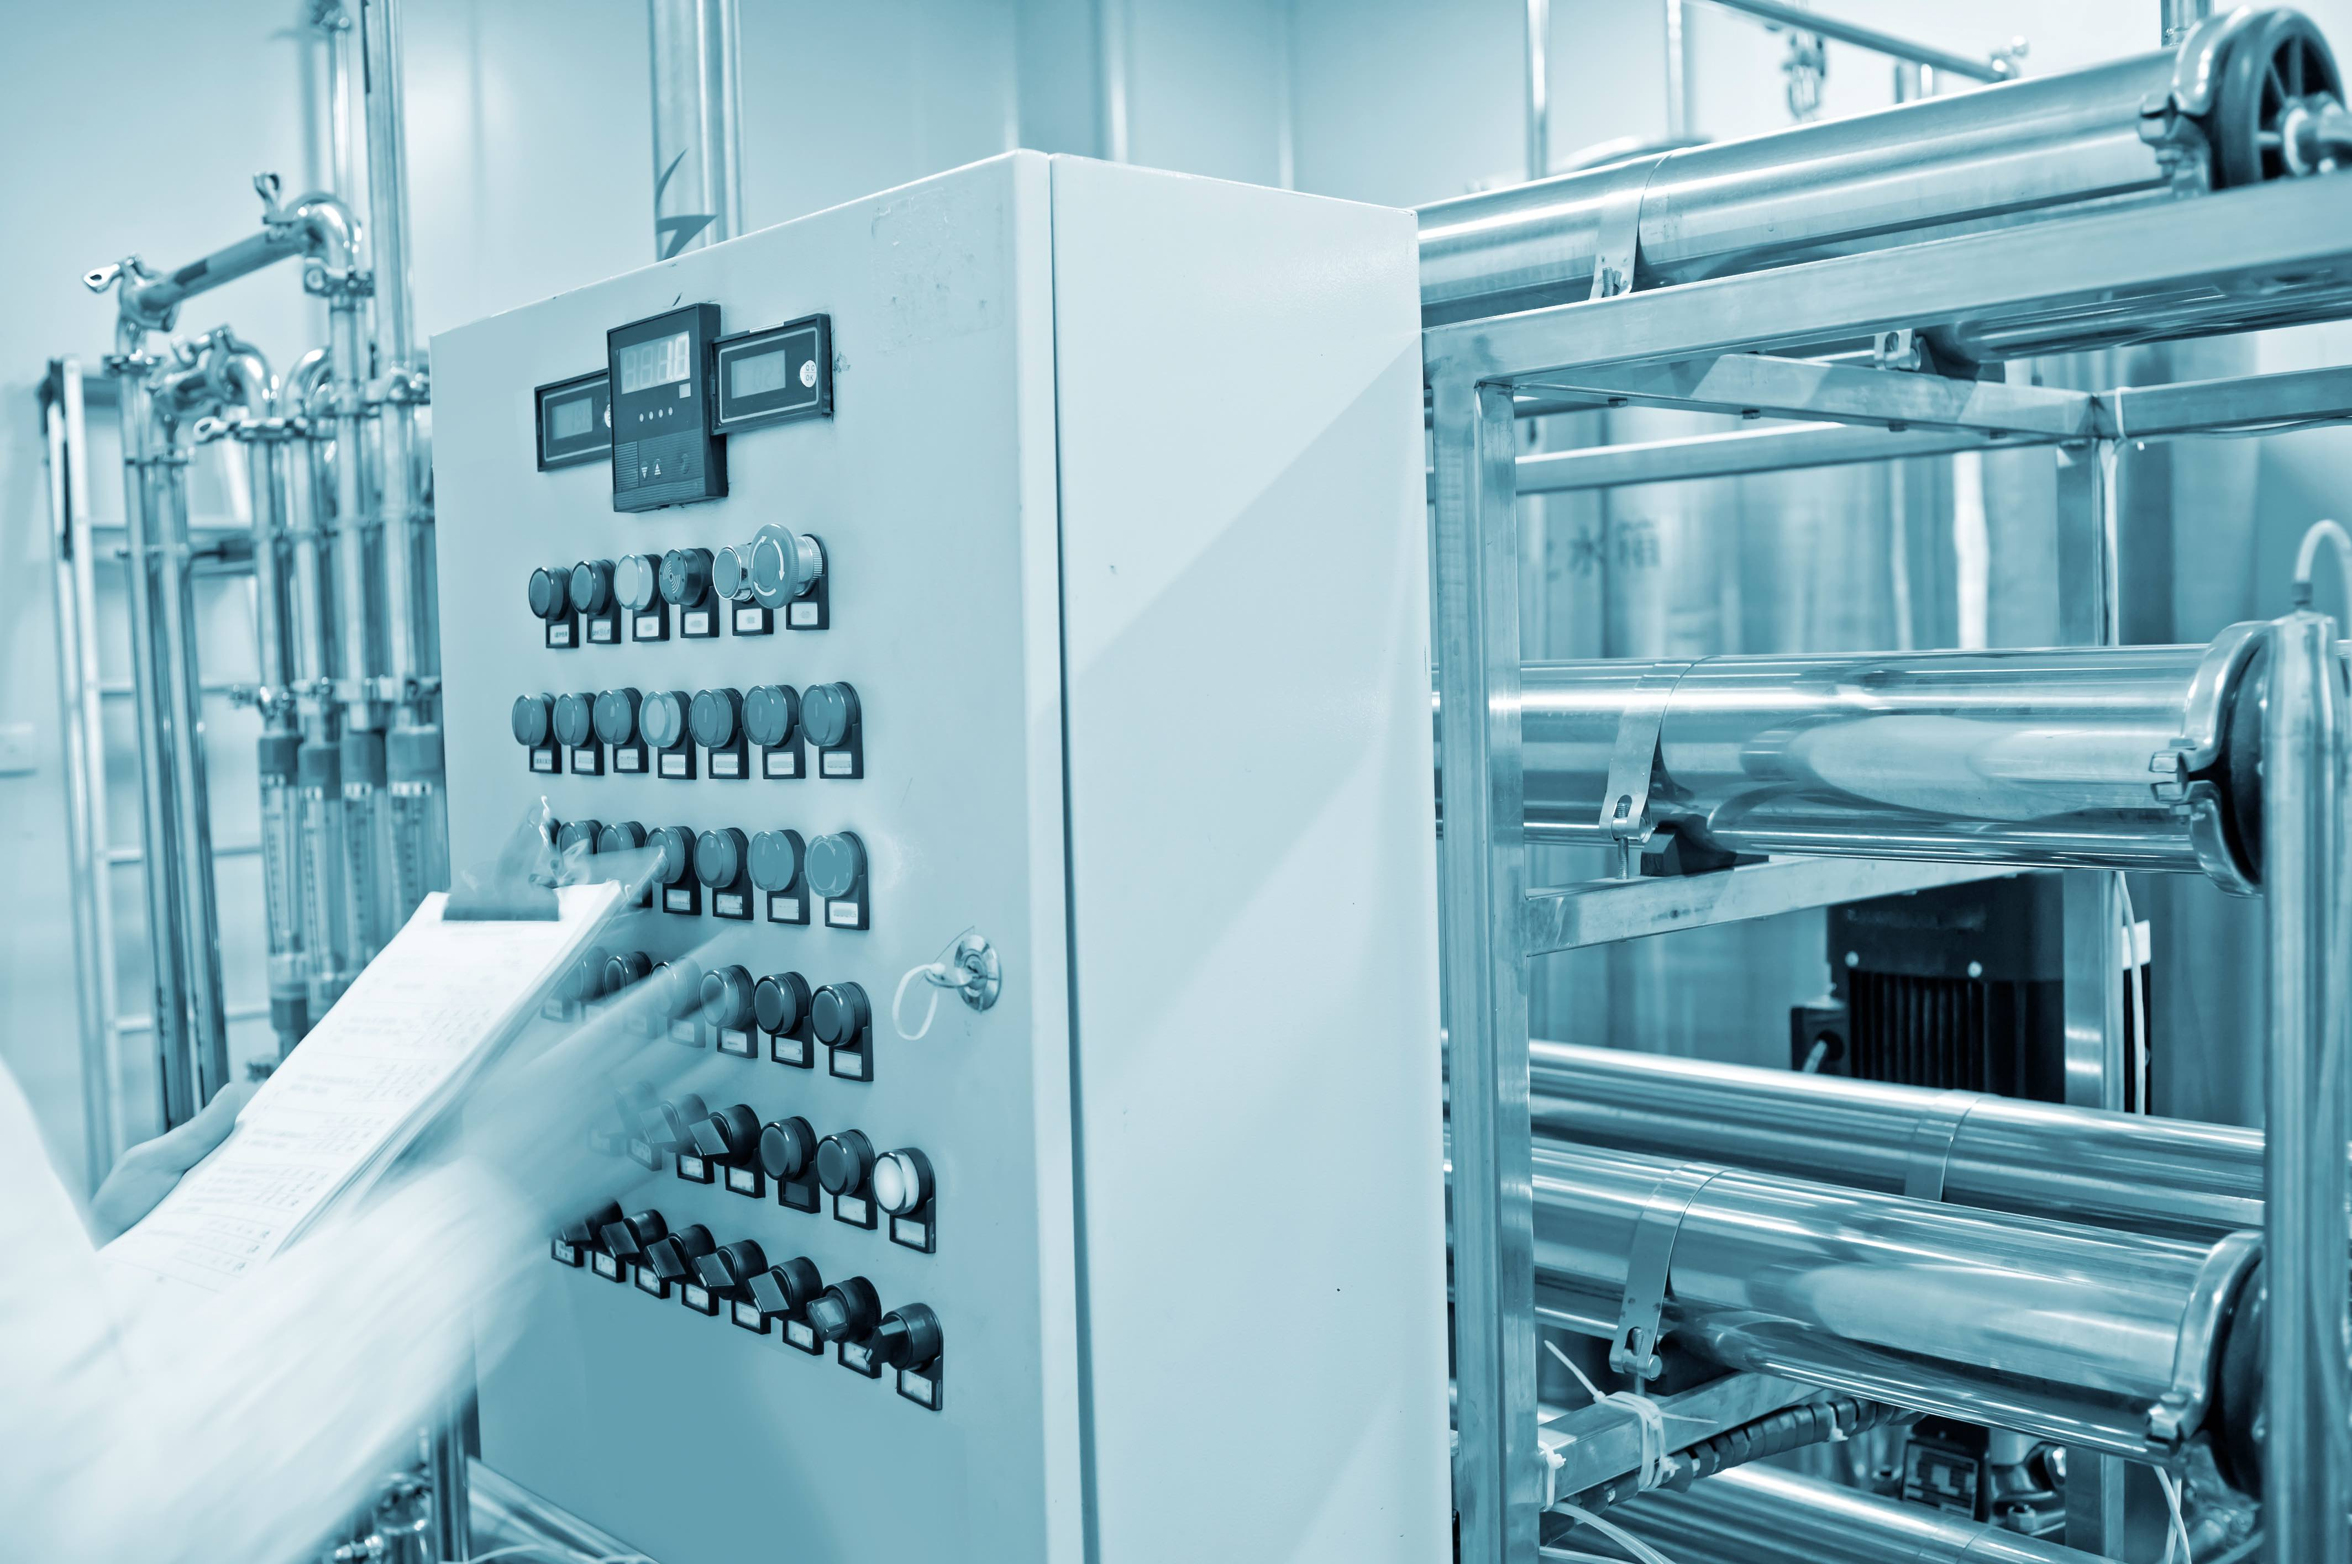

Wednesday, October 10, 2018
4:00 - 7:00 pm

Sponsorships Available

Location: CRB
100 N. Pacific Coast Highway, Suite 600
El Segundo CA 90245

Host: Mark Mourey, Director Business Development, CRB

Program Manager: Paul Crissman, Principal, Biotechnical Solutions

Speakers:
Nissan Cohen, Sales Director, Aqua-Chem, USA
Jarrod Wrampe, Process Utilities Engineer, CRB

Background:
1) The first revision to Annex 1 in a decade has rebuilt and reorganized the document to align with GMP in Europe. New sections on scope, utilities, environmental monitoring, and process monitoring; a reorganized and restructured content for a more logical flow; and the introduction of QRM principles make the new and improved Annex 1 critically important for the pharmaceutical industry.
2) European Pharmacopeia recently changed to allow membrane as well as distillation for water production.

3) ISPE Baseline Guide for Pharmaceutical Water Systems Revision 3 to be released shortly

Come learn about all these important developments.

Water
Global Regulatory Changes
and Impact on your Company
Evening Meeting

Wednesday, October 10, 2018
4:00 - 7:00 pm

Schedule:
4:00 - 5:00 pm Registration and Networking
5:00 - 5:30 pm Appetizers and Networking
5:30 - 6:00 pm European Pharmacopeia Changes to Water Production
Speaker: Jarrod Wrampe, Process Utilities Engineer, CRB
6:00 – 6:50 pm Annex 1
- Who is Responsible
- What is the Enforcement
- What it means to your Company
Updating the Baseline Guide for Pharmaceutical Water Systems
Speaker: Nissan Cohen, Sales Director, Aqua-Chem, USA
6:50 - 7:00 Q&A

About the Speakers:
Jarrod Wrampe has over 17 years of experience as a process utility engineer and project manager at CRB. His current design duties include the development of process and instrumentation diagrams (P&IDs), equipment specifications, equipment plans, piping plans and architectural drawings. Jarrod frequently functions as the client’s primary interface for both design and project management. Jarrod’s experience as a design lead and project manager allow him to understand the entire project from inception to completion across multiple disciplines, making him an integral part of every phase of the design team.

Nissan Cohen, an ISPE member since 1994, is a worldwide expert in total organic carbon, high purity, ultrapure, reclaim-and-recycle water systems, with profound expertise in instrumentation, automation, and organic contamination oxidation systems using ozone, UV, ion exchange and catalysts. He is also the co-chairman of the ISPE Baseline Guide revision for Water and Steam Systems.

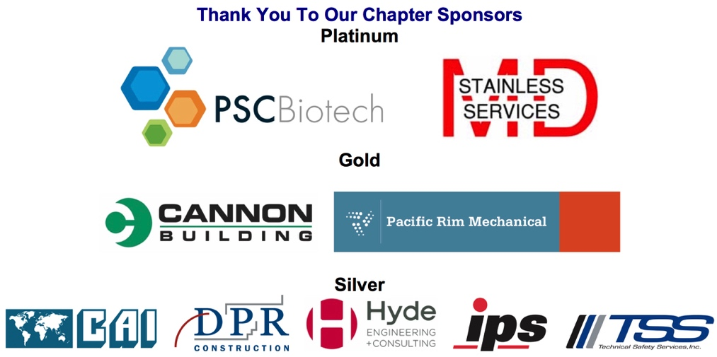

REGISTRATION FORM and INSTRUCTIONS
Water - Global Regulatory Changes and Impact on your Company
Wednesday, October 10, 2018

Name badges will be given at the event. For an immediate receipt, please use the Chapter's online processing system: http://atdevents.net/register.php

ISPE LA, SD, SF Members: If you are an ISPE Member in California, please do not set up a new account as you should already be in our system. Please email Rob Fleming for assistance with your username and/or password.

ISPE Members of other Chapters: You will not be in our system unless you have previously set up an account. Please follow instructions for Non Members below. To update your account to a Member account, please forward your confirmation email from ISPE or ISPE Membership Card to Rob Fleming (rob.fleming@yahoo.com). We need your Chapter name, your ISPE Member number and expiration date. You can get your Membership card once logged onto the ISPE website. (Go to "Account/My Account" then "Print Your Membership Card" on left side of the screen towards the bottom).

Non Members: If you do not have an account on our system, you can set one up on the site using all letters (no numbers) for your username.

Fax Registration: Complete the Registration Form with a credit card payment and Fax to (949) 266-8461.

Pay by Check: Register online. Under "Payment Type" select "Company or personal check" or fax your registration form to
(949) 266-8461. Then mail your check no later than one week prior to the meeting to ensure it is received in time.
Make checks payable to: ISPE Greater Los Angeles Chapter, 5319 University Dr., Suite 641, Irvine, CA 92612. Tax ID#95-4452996.

Registration Help, setting up your account, having problems with online registration, need to reset your password, questions regarding registration or receipts? Email Rob Fleming (rob.fleming@yahoo.com).
Cancellations must be received in writing via fax or email to Rob Fleming by October 1, 2018 for refund. After the cancellation date if you have reserved a space but do not attend, your payment MUST be remitted.

Name badges will be given at the event.
________$65 ISPE Members
________$90 Non-Members
________$40 YP Members (requires ISPE YP Membership designation)
________$500 Event Sponsor (includes 2 attendees and a table top at the event)
________FREE for first 20 CRB Employees
________First 5 Students Free
________$30 Government, Additional CRB Employees and Students
If paying by credit card, please check type: ____ VISA ____ MASTERCARD ____ AMERICAN EXPRESS
Name on Card:__________________________________ Signature:__________________________________
Card #:_______________________________________________________________Expiration Date:_______
Please cut and paste your contact information here, or fill in the appropriate spaces:
FIRST/LAST NAME:
E-MAIL:
TITLE: PHONE:
COMPANY:
ADDRESS:
CITY: STATE: ZIP:
CRB
100 N. Pacific Coast Highway, Suite 600 El Segundo, CA. 90245
(*Please note – Due to the street name recently changing from Sepulveda to PCH, your directions may affect via google maps or any smartphone directions app. Just make sure that the city states El Segundo versus Redondo Beach.)

Southbound 405
- Exit 105 West towards El Segundo
- Exit at 1B, follow signs for CA-1 South
- Do a U-Turn at El Segundo Blvd to go back North on Pacific Coast Highway
(Previously Sepulveda Blvd.)
- Immediately pull into Parking Structure (Between Buildings 200 and 222)
- As soon as you enter Parking Structure you will turn to the right for visitor parking
- We are in the 100 Building, park as close as you can to 100 building
Northbound 405
- Exit 44 to El Segundo Blvd.
- Turn left onto El Segundo Blvd.
- Turn right on Pacific Coast Highway (Previously Sepulveda Blvd.)
- Immediately pull into Parking Structure (Between Building 200 and 222)
- As soon as you enter Parking Structure you will turn to the right for visitor parking
- We are in the 100 Building, park as close as you can to 100 building

Once you have parked, please take elevator (or stairs) to plaza level, then enter the 100 Building
and take elevator up to the 6th floor, exit elevator and once you have stepped out you will see
suite 600 right away to the west.

