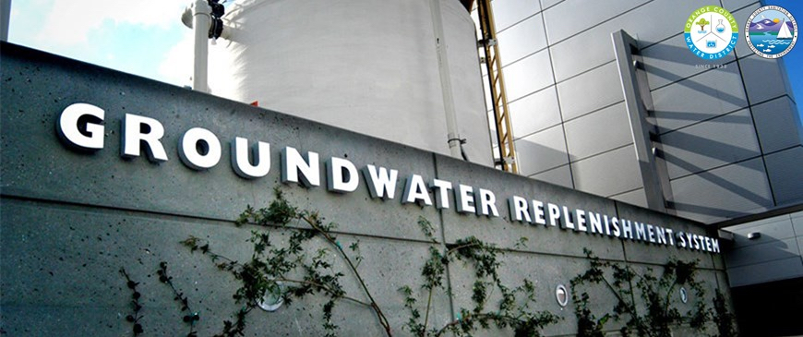

O.C. Water District Waste Water Treatment Facility Tour
Thursday August 9th, 2018
5:00 to 7:30 pm

Location:
OC Water District
18700 Ward Street, Fountain Valley, CA 92708

Hosts and Program Managers:
Becky Mudd, OCWD Community Outreach Coordinator
ISPE GLA Young Professionals Committee

Schedule:
5:00-5:30PM Registration and Networking
5:30-7:30PM Presentation and Tour of Facility

About the Event:
Come join ISPE Los Angeles Chapter for a unique opportunity to tour the World Record holding OC Waste Water Treatment Facility in Fountain Valley. This facility hold the record for the most waste water recycled to drinking water in a 24 hour period. The facility produces 100 million gallons of purified water a day. This event will include a presentation about the facility and an extensive tour of the site.

Please bring identification for check in, no walk-in registration permitted. Sponsorships Available.

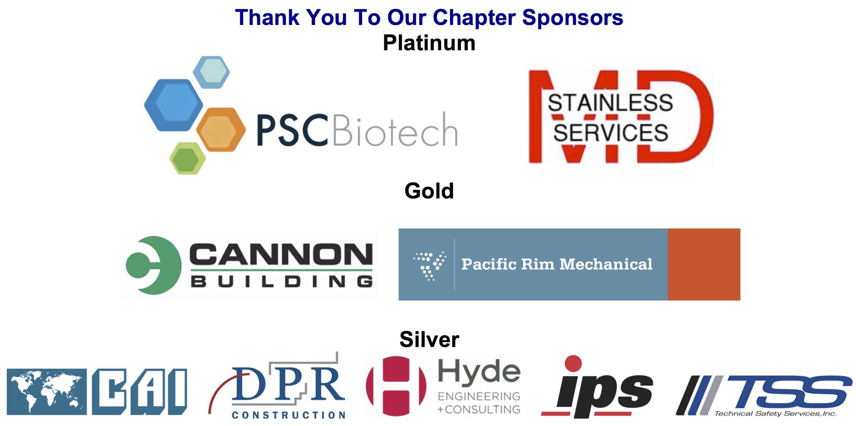

REGISTRATION FORM and INSTRUCTIONS
O.C. Water District Waste Water Treatment Facility Tour

Thursday August 9th, 2018

Name badges will be given at the event. For an immediate receipt, please use the Chapter's online processing system: http://atdevents.net/register.php

ISPE LA, SD, SF Members: If you are an ISPE Member in California, please do not set up a new account as you should already be in our system. Please email Rob Fleming for assistance with your username and/or password.

ISPE Members of other Chapters: You will not be in our system unless you have previously set up an account. Please follow instructions for Non Members below. To update your account to a Member account, please forward your confirmation email from ISPE or ISPE Membership Card to Rob Fleming (rob.fleming@yahoo.com). We need your Chapter name, your ISPE Member number and expiration date. You can get your Membership card once logged onto the ISPE website. (Go to "Account/My Account" then "Print Your Membership Card" on left side of the screen towards the bottom).

Non Members: If you do not have an account on our system, you can set one up on the site using letters (not numbers) as your username.

Fax Registration: Complete the Registration Form with a credit card payment and Fax to (949) 266-8461.

Pay by Check: Register online. Under "Payment Type" select "Company or personal check" or fax your registration form to
(949) 266-8461. Then mail your check no later than one week prior to the meeting to ensure it is received in time.
Make checks payable to: ISPE Greater Los Angeles Chapter, 5319 University Dr., Suite 641, Irvine, CA 92612. Tax ID#95-4452996.

Registration Help, setting up your account, having problems with online registration, need to reset your password, questions regarding registration or receipts? Email Rob Fleming (rob.fleming@yahoo.com).
Cancellations must be received in writing via fax or email to Rob Fleming by July 31, 2018 for refund. After the cancellation date if you have reserved a space but do not attend, your payment MUST be remitted.

Name badges will be given at the event.
________FREE YP (Young Professionals) ISPE Members
________FREE Students
________$20 ISPE Members
________$35 Non-Members

If paying by credit card, please check type: ____ VISA ____ MASTERCARD ____ AMERICAN EXPRESS
Name on Card:__________________________________ Signature:__________________________________
Card #:_______________________________________________________________Expiration Date:_______
Please cut and paste your contact information here, or fill in the appropriate spaces:
FIRST/LAST NAME:
E-MAIL:
TITLE: PHONE:
COMPANY:
ADDRESS:
CITY: STATE: ZIP:

