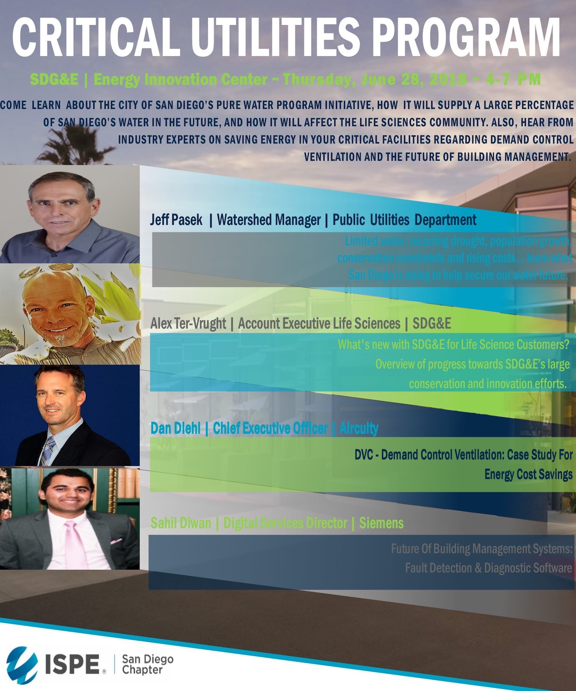

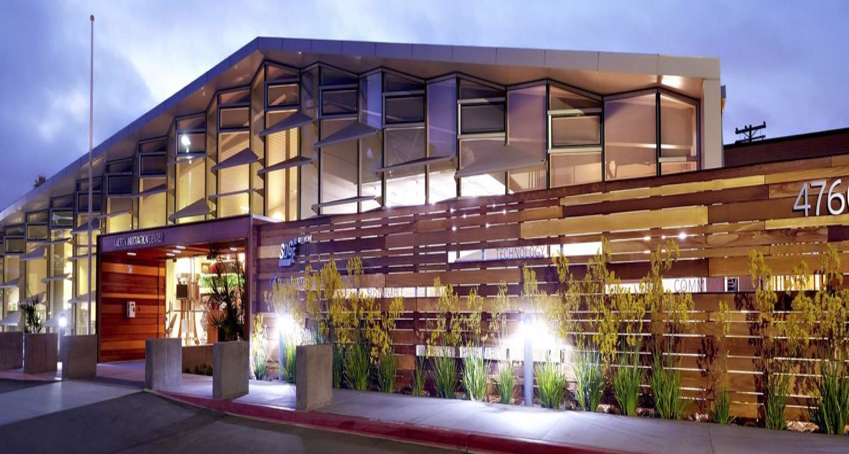
Critical Utilities Program

Thursday, June 28, 2018
4:00 pm - 7:00 pm

at SDG&E Energy Innovation Center
A Double LEED® Platinum Facility
4760 Clairemont Mesa Blvd.
San Diego, CA 92117

Program Managers:
Deborah Neatherlin, Senior Sales Executive Life Sciences, Siemens
John Wammes, President/CEO, Water Works Inc.

Schedule, Speakers and Topics to Be Covered:
4:00 - 5:00 pm Registration and Happy Hour/Networking
5:00 - 7:00 pm Presentations

Alex Ter-Vrugt, Account Executive Life Sciences, SDG&E (15 minutes)
What’s new with SDG&E for Life Science Customers?
Overview of progress towards SDG&E’s large conservation and innovation efforts.

Sahil Diwan, Digital Services Director, Siemens (30 minutes)
How are Building Management Systems Changing? What to expect for the future?
Overview of Fault Detection and Diagnostic Software.

Dan Diehl, CEO, Aircuity (30 minutes)
What is Demand Control Ventilation? How can you apply it to your critical facility? Local Case Study.

Jeff Pasek, Watershed Manager, City of San Diego Public Utilities Department (30 minutes)
With limited and imported water supplies, rising costs, recurring drought and population growth, come learn what the City of San Diego is doing to help secure our water resource future and how it will affect our industry. With the initial phase completed by 2023, the Pure Water San Diego potable reuse program will provide a safe, reliable and cost-effective drinking water supply for San Diego.

Sponsorships Available

ISPE San Diego Chapter

Registration Instructions

To Register and Receive an immediate receipt, use our on-line registration: http://atdevents.net/register.php

ISPE LA, SD, SF Members: If you are an ISPE Member in California, please do not set up a new account, you should already be in our system. Please email Rob Fleming for assistance with your username and/or password.
ISPE Members of other Chapters: You will not be in our system unless you have previously set up an account. Please follow instructions for Non Members below. To update your account to a Member account, please forward your confirmation email from ISPE or ISPE Membership Card to Rob Fleming. We need your Chapter name, your ISPE Member number and expiration date. You can get your Membership card once logged onto the ISPE website (see bottom left side of the screen).
Non Members: If you do not have an account on our system, you can set one up on the site using letters (not numbers) as your username.
**Students: The Student Rate is for individuals who are enrolled full time in a related academic program at an accredited institution. The Student Rate does not apply to working professionals taking one or two courses on the side. To verify your status as a student, we may ask you to supply your student ID and copy of current class schedule. Final eligibility determined by ISPE SD.
Registrations can also be faxed. Complete the form and fax to 949-266-8461.

If paying by check, please mail your check made payable to:
ISPE SAN DIEGO CHAPTER, 5319 University Dr., Suite 641, Irvine, CA 92612 • 949-387-9046
ISPE San Diego Chapter Tax ID#33-0551783

Registration Fees Include:
Presentations (if approved by the speakers), Appetizers and Happy Hour drinks.
FREE for SDG&E Employees
ISPE Members $70
Non Members $100
REDUCED Student Pricing First 5 Students Free then $30 per student
Sponsors $500 (includes table and two attendees)

Note: If you are between jobs or your company does not support your registration fees, please contact Kimberly Syre (ksyre@cox.net) for reduced fee options or sponsorship opportunities.

Registration or Online Questions? Contact Rob Fleming: rob.fleming@yahoo.com
Any other Questions, Contact Kimberly Syre: ksyre@cox.net

Name Badges will be given at the event.

Cancellations must be received via email to: ksyre@cox.net by June 19, 2018 for refund. After the cancellation date if you have reserved a space but do not attend, your payment MUST be remitted, however, an alternate person may attend in your place. If the alternate is not a member, they will need to pay the additional amount for non-members. Name badges will be given at the on-site registration desk.

Registration Form for Innovative Utility Technologies
Thursday, June 28, 2018 from 4:00 pm - 7:00 pm

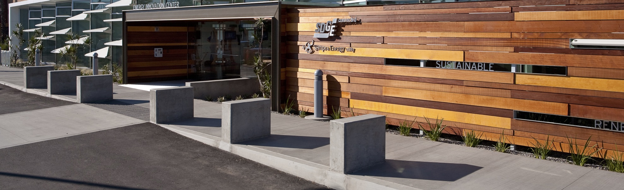

REGISTRATION RATES

___________$70 ISPE Members ___________$100 Non-Members

___________Free SDG&E Employees

___________Free First Five Students ___________$30 Additional Students (if free spots are taken)

___________$500 Sponsors (includes table and two attendees - please supply names with email below)

CREDIT CARD PAYMENT - Please Indicate Type of Credit Card
________ VISA ________ MASTERCARD ________ AMERICAN EXPRESS

Name on Card_______________________________________Signature: _________________________________

Credit Card #: ______________________________________________________________Exp Date:____________

YOUR CONTACT INFORMATION:

First and Last Name:

Title:

Company:

Address:

City: State: Zip:

E-Mail:

Phone: Fax:

Driving Directions and Special Instructions:

SDG&E Energy Innovation Center
4760 Clairemont Mesa Blvd.
San Diego, CA 92117

The Energy Innovation Center is a sustainable facility.
Please join us in our commitment to help the environment by participating in our green initiatives:
- Carpool and park under the cool shade of our Solar Trees
- Use public transportation whenever possible
- Walk or Bike (secure bike racks available on site, please bring your own lock)
- Follow our recycling and waste management practices at the Center

From Downtown San Diego
Take 163 Freeway North to 805 Freeway North.
Take exit 22 for Clairemont Mesa Blvd.
Keep left, follow signs for Clairemont Mesa Blvd W and merge onto Clairemont Mesa Blvd.
Destination will be on the right.

From Oceanside
Take 5 Freeway South to 805 Freeway South.
Take exit 22 for Clairemont Mesa Blvd.
Keep right, follow signs for Clairemont Mesa Blvd W and merge onto Clairemont Mesa Blvd.
Destination will be on the right.

Please be sure to look up directions from your own starting point.

